Compiler Design

CS6109 - Project Abstract

Predicting and Classifying Interests of Users based on Direct Interactions

Vivek Ramkumar, 2018103082

Kariketi Tharun Reddy, 2018103034

G. R. Srikanth, 2018103603

Introduction:

The basis of our project is to provide a textual analysis of the interactions between multiple users, and predict their interests, as well as categorize them. This is an important function of recommendation systems, that is, to offer a personalized experience for each user, by understanding their preferences. Direct interactions between users will be subject to lexical, syntax and semantic analysis, from which we will obtain their preferences to items, as well as actions and hobbies.

Modules:

We will employ the standard principles of compiler design, up to intermediate code generation. Lexical, syntax and semantic analysis will be used in the following order to analyze the input text:

* Identify keywords(chicken, leather bag, smart phone) and verbs in the continuous sense(eg. eating, playing) and such, using lexical analysis.
* Correct spelling mistakes and check for proper suffixes to the tenses, removing unnecessary characters, and other such error checks, by using syntax analysis.
* Check for meaning to thus obtained terms and interpreting them, by using semantic analysis.

The result will be an organized collection of information obtained from the interaction, showing the preferences and their respective categories.

How it works:

Vivek: *I like using the mongoose cricket bat to play with my friends.*

Tharun: *I enjoy drinking coffee and playing carrom board with my family.*

Srikanth: *I find table tennis a refreshing activity to play with my family as well.*

The interactions between these three users will be sent through the three analyzers in respective order(lexical, syntax and semantic) and their preferences will be classified and obtained as follows:

**Please note: This is **not** an accurate depiction of the final result.**

Vivek -> Item: mongoose, bat

Interest: animal, cricket

Action: using, play

Classification: Sports, Pets

Recommendation: cricket bats, cricket gear, sports gear, etc.

Tharun-> Item: coffee, carrom, board

Interest: coffee, carrom board

Action: drinking, playing

Classification: Beverages, Sports

Recommendation: Cothas Coffee, carrom boards and pieces, etc.

Srikanth-> Item: table, tennis

Interest: tables, tennis

Action: play, refreshing

Classification: Sports

Recommendation: table tennis tables, bats, balls, etc.

Common topics: Sports

If we evaluate Vivek alone on his statement, it could recommend animals, but they are eliminated on the basis of a common topic, as neither Srikanth nor Tharun talk about animals, but they all talk about sports.

Architecture Diagram:

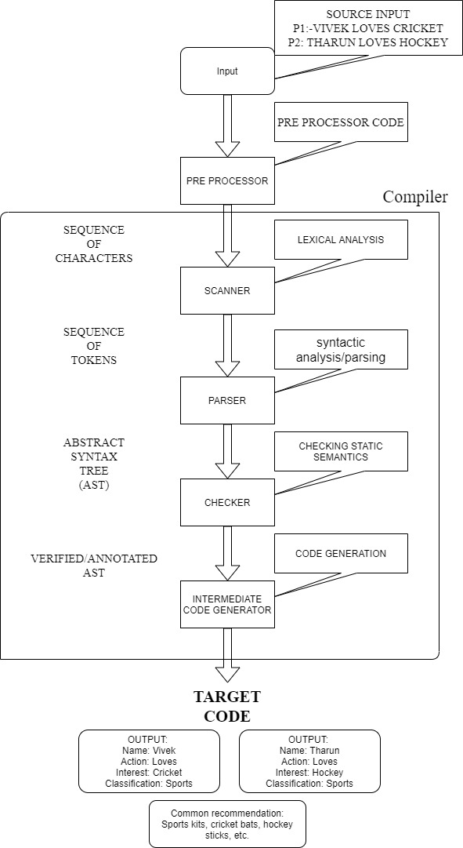

Conclusion:

The information obtained from direct interactions can be a valuable tool, as we can create recommendation systems on the basis of user-user interactions, such as comments on a forum, rather than user-site interactions.

Previous systems understand and provide recommendations based on similarities between users, which might lead to a bias evaluation for user preferences. This provides a solution for this issue by integrating direct interactions into recommendation systems.

However, there is still much left to improve, and a full accuracy of such systems is never guaranteed, but this approach will definitely up the bar in extending further recommendation systems.

References:

C.Li, F.Xiong, “Social Recommendations with Multiple Influence from Direct User Interactions”, Aug. 2017.